Introduction
Objective list theories believe the existence of objective prudential goods: even though one can be a couch potato, he/she chooses more virtuous activities to approach happiness(Haybron, 2020). Nevertheless, individuals still have subjective understandings toward objective goods, which I refer to one’s essential state of happiness.
Based on this understanding toward happiness, I adopt the logic of “Four Fields of Knowledge” (Schumacher, 1978) to illustrate the two processes of effective measurement :
- Respondents have a clear understanding toward their personal happiness (I - inner)
- They convey their sense of happiness accurately and completely to the test (inner-externality)
However, insurmountable barriers hinder the satisfaction of these two processes. Therefore, this essay argues that happiness cannot be measured by subjective well-being test (SWB) (Stone et al., 2013).

First process: realization toward the self
In Tao Te Ching, Lao-Tzu believes that “ He who knows himself is enlightened.” Knowing oneself is to discover one’s feeling, thoughts, and beliefs fully (Gertler, 2020). And since happiness is an inner experience, knowing will be the zero condition to discover one’s essential state of happiness.

Because happiness blends inseparably with physical sensation, one’s knowledge toward externality will first affect one’s knowing. To learn the external world, Locke writes, “Tis therefore the actual receiving the ideas from without that gives us notice of the existence of other things (Rockwood, 2018).” That means the knowledge about externality doesn’t build from established beliefs toward externality, but is from our raw sensation. To discern these two sources, individuals’ perception needs to be a “dynamic searching for the best interpretation of available data” (Gregory, 2015), and I interpret this search as self-consciousness.

Being self-conscious takes two steps. By invoking system 2, individuals first direct their attentions to effortful mental activities and once autopilot behaviors, providing a threshold of gaining subjective experiences (Kahneman, 2011). Nearly simultaneous, metacognition involves to monitor one’s cognitive states, ensuring individuals view one’s own thoughts critically. The activation of system II and metacognition pushes an individual to the boundary of known, and the process of taking unknown into known is self-conscious.

However, barriers hinder human beings to discover the self. Biologically speaking, human beings have natural tendency to conserve energy and thus evade the activation of system II, especially on tasks that can be done with system I (Kahneman, 2011). Moreover, without mindfulness, the attentions on externality is likely to be divided in form that hard to be realized by the self. As Corteen and Wood (1972) has discovered, when words didn’t consciouslly perceived by participants, they still established meaning in their minds. With all barriers of realizing the self, Kants says a man cannot “determine with certainty what would make him truly happy; because to do so he would need to be omniscient. (Kant, 1889)”

The idea of being omniscient is to transcend and discover one’s essential state of happiness. But even if a being believes that he attain a sense of happiness, it may be a fallacy and not the known. To illustrate this claim, I adopt the Tal Ben-Shahar’s (2007) model and analyze possible cognitive limitations that hinder each archetype to transcend. For every individual has a belief toward present happiness and future happiness, one can fill into a quadrant.
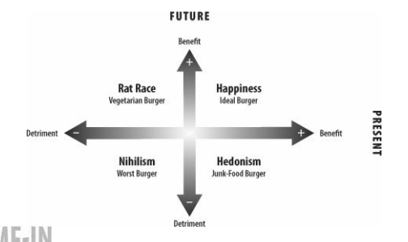

Future
Benefit

Happiness
Rat racer

Benefit Now
Detrimental
Nihilism
Hedonism

Detrimental

Hedonism: ultimate happiness is attained
By taking psychoactive drugs and performing religious behaviors, human beings can intentionally alter their states of consciousness (Cacioppo & Freberg, 2019, p. 215). With this artificial change of beliefs, hedonistic drug takers regard instant satisfaction as happiness and disregard their future. However, if happiness exists in form of eudamonia, the overall experience in life is related to one’s experience toward happiness. Since hedonists blind future possible happiness, transcendence can only occur when they realize the mistake of regard instant excitement as ultimate happiness.
Overall achievement--needs further clarification, even include the events after death.[ oxford handbook of happiness]

Nihilism: happiness died
During the World War II, numerous people failed into learned helplessness and believed that they loss both present and future happiness. According to Karl Jasper’s theory, they fail into a “limit situation”, beliving that only external locus of control exsit (Valdes-Stauber, 2016). However, limit situation also can “becomes one’s destination in the realisation of one’s exisence”, provoking people to ask higher happiness (Jacobsen, 2008). Frankl (2006) accept his unavoidable sufferings bravely, believing potential meaning is possible to find within. People with serious chronic diseases learn to adapt their impairments, redempting and transcending themselves (Charmaz, 1995). Thus, if the higher happiness integrates the meaning of pain, nihilists evaluate their happiness based on their “existence” rather than their “essense” (Sartre, 1946), disregarding the potential of transitoriness.

Happiness: distinction between evaluation and beliefs
Happiness is the archetype that has the highest possibility of approaching the knowing, since they believe that they have the potential of discovering one’s maxim of happiness. With the belief to transcend, they take happiness more as a dynamic skill that detaches from established experiences and momentary states. However, while the perception turns to explicit rating within oneself, possible bias may occur during the construction of frame. For instance, about what contribute to one’s happiness, individuals take certain aspects as the main cause, but the ignored intricate associations among these aspects are also essential for gaining happiness. As gestalt psychology illustrated, one’s understanding “seem to depend upon relations among the stimuli rather than upon the individual stimuli as such (Kohler, 1967).” Therefore, the transition between perception and evaluation can undermine the known.

Rat Racer: serving for happiness
Rat racers “subordinate the present to the future” and “suffer now for the purpose of some anticipated gain” (Tal Ben-Shahar, 2007), regarding their sacrfice in present happiness is meaningful. However, this destiny orientated purtsuit ignore the impact of the shift in reference points. Under this “finite game” (which is played for the purpose of winning)(Carse, 2012), rat racers keep aiming for a higher reference point and leave themselves in state of loss. Due to loss aversion, same amount of gain from the past and loss from now cannot subjectively offset each other (Kahneman, 2011). Without possible transcending, which is to gain happiness from journey, rat racers accumulate their loss and search happiness continuously with improper direction.
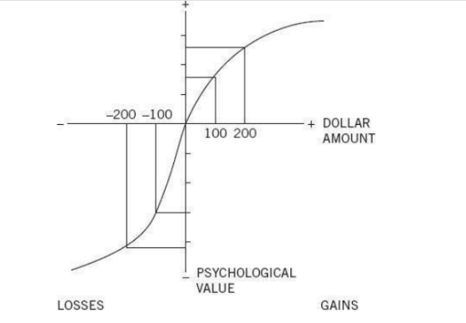

Second process: the interaction between internality and externality
Now the respondents need to convey their understandings to the test. To ensure the second process proceeds successfully, two conditions need to be satisfied:
2.1)Individuals are willing to convey their understanding toward externality fully and accurately
2.2)externality construct a frame that is able to capture individuals’ understanding fully

Firstly, for 2.1 condition, intension of the test can strongly affect individuals’ willingness. If the test aims to achieve externality’s purpose, such as collecting data for scientific research, moderate anonymity facilitate collection of more authentic report by lowering social desirability pressures (Lelkes et al., 2012) However, if the respondents regard the measurement as a way of knowing himself, one main question will rise: can a man be honest to himself when he/she stays alone?

The existence of cognitive dissonance can undermine respondents willingness to convey their understanding. For rat racers, reporting a high level of happiness (action) allows respondents to stay consistent with social expectation of wealth and fame (belief), even though they realize the lack of happiness. Moreover, under the value system that “unhappiness is a symptom of maladjustment” (Frankl, 2006), respondents may hide their willingness more to conform social desirability and to reduce their cognitive dissonance .

Secondly, to satisfy 2.2 condition, an effective frame first needs to ensure the testing questions are able to capture all respondents personal understandings. Therefore, researchers use “meaning” in test without clarification, or a broad definition such as “as the sense made of” (Steger et al., 2006). But the lack of precision means respondents personal understandings need to be clear. If the first process fails, the 2.2 condition will hard to be achieved.

Alternatively, the test can turn to be more precise by including more potential factors, such as “nonhedonic sources of happiness and suffering (Stone et al. ,2013).” However, precision can bring more challenges. For instance, confronting a challenge successfully can bring competence, which is normally regarded as a promoter of happiness. However, if respondents feel a lack of autonomy, comptence then cannot enhance their happiness (Ryan & Deci, 2000). Therefore, if the measurement improve the evaluation by incorporating more correlated sources, such as competence, it needs to take even more correlated factors to ensure the test to be unbiased.

Not only does the trade off between broadness and precision can brings a challenge, but also the cognition of society can limit the frame of test. Influenced by culture, measurement in collectivism society attaches more importance on contribution toward group, likely to regard these efforts are more eudamonic than personal growth. Influenced by the features of an era, society’s understanding toward happiness diverges with individuals’. For instance, in Song dynasty, Su Tungpo spoke truth to power and thus was exiled to undeveloped land such as Lingnan. Even though he suffered, he still perceive a strong sense of happiness, expressing that in his poem: “with three hundred litchis every day and night; I am willing to be a Lingnan man for the rest of my life.” (Lin, 2018) The society aimed to suppress him and reduced his happiness, but Tungpo “amor fati”--love his fate (Han-Pile, 2009). This diverged interpretations means if the externality construct a measurement, it would hardly be not biased.

More importantly, individuals can hardly falsify that society and individual have diverged understanding toward happiness. For instance, It is convincing that social connection can promote the development of self-esteem (Maslow, 1943), but is it possible that society overly reinforces the role of externality on one’s happiness? Under the encouragement of social network, one may falsely regard solitude as loneliness. Therefore, individuals intrinsic understanding toward happiness can be veiled. Society believes the test enhances its convergent validity, but is this still individuals’ subjective well-being? Or is it more about society-encouraged wellbeing?

Conclusion
This essay argues happiness cannot be measured by subjective well-being test (SWB) by examining two processes. First, when a man evaluates his/her inner-happiness, he/she first needs to approach the state of knowing. However, even if the man believes that he/she achieves knowing, he/she may hindered by cognitive limitations as explained by archetype analysis.
Second, when the respondents convey their understandings to the test, their willingness to convey and the tests’ frame affect the extent that happiness is reflected. Respectively, cognitive dissonance can undermine one’s willingness to convey, and the trade of between broadness and preciseness brings challenges to construct questions.
Last, I argue that the frame of test is highly influenced by society’s cognition, but not based on individuals’ cognition. This divergence between individuals and externality’s cognitions can hardly be proved under the influence of mainstream culture.

The construction of test is limited by social cognition.
科学，精度

